* **Inventory Management module: -**
* Click on Inventory Management on dashboard

**1. Inventory Master: -**

* Click on Add Inventory

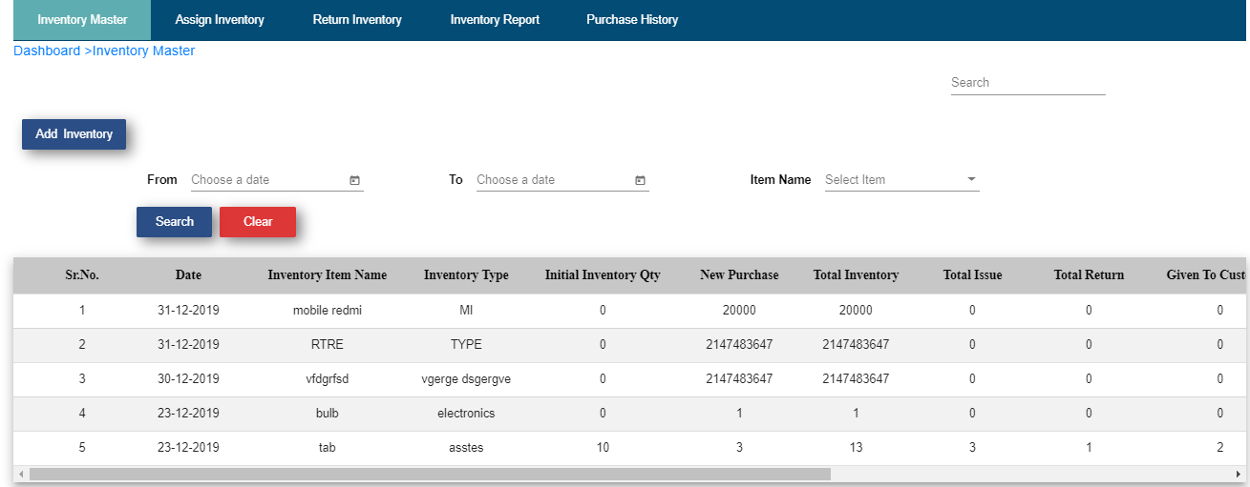

* Fill up the Form
* Click on Create button
* If you want to cancel then click on Cancel button

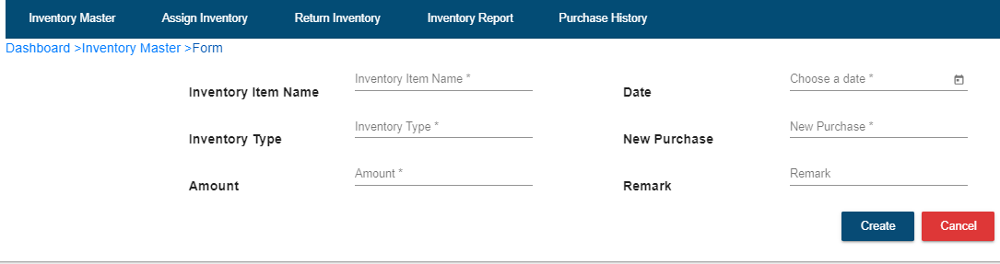

* You will get Popup message “Record Inserted Successfully”, and OK button. Click on OK button.
* New Created inventory item get added into inventory item master.
* User is able to edit/ delete inserted record by clicking on edit/ delete icon present in operation column.

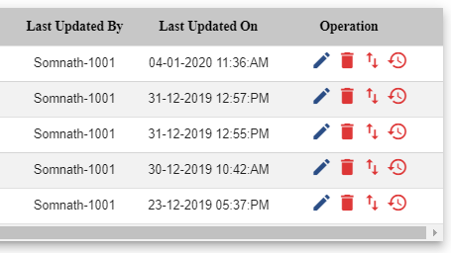

* User is able to download action performed on particular record i.e. action logs follow below steps:
* Click on upward/downward arrow icon present in operation column. If you click on that icon then you will get the popup window with message “Export Action Log for this record?” with Cancel and OK buttons



* If you want to download then click on Ok otherwise click on cancel
* If you click on OK excel sheet get downloaded like below mentioned sheet.



* User is able to download history of particular record follow below steps:



* Click on clock icon present in operation column. If you click on that icon then you will get the popup window with message “Export history for this record?” with Cancel and OK buttons.
* If you want to download then click on Ok otherwise click on cancel
* If you click on OK excel sheet get downloaded.

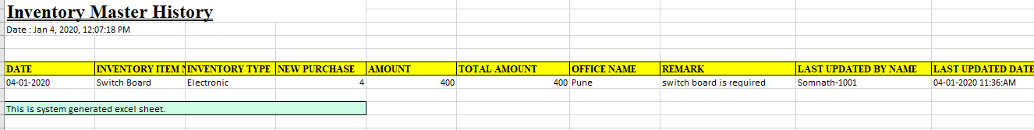

* User is able to search inserted records by date
* Choose From date
* Choose To date
* Click on search
* User is able to search inserted records by Item name
* Select item name from dropdown list
* Click on search
* Clear entered fields by clicking on clear button

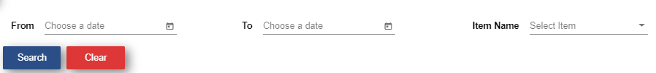

**2. Assign Inventory: -**

* Click on Add Assign

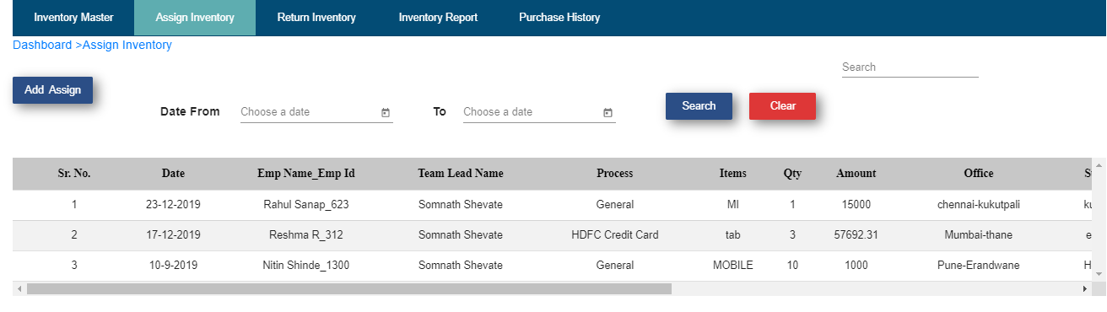

* Fill up the form
* Click on create
* Click on Ok

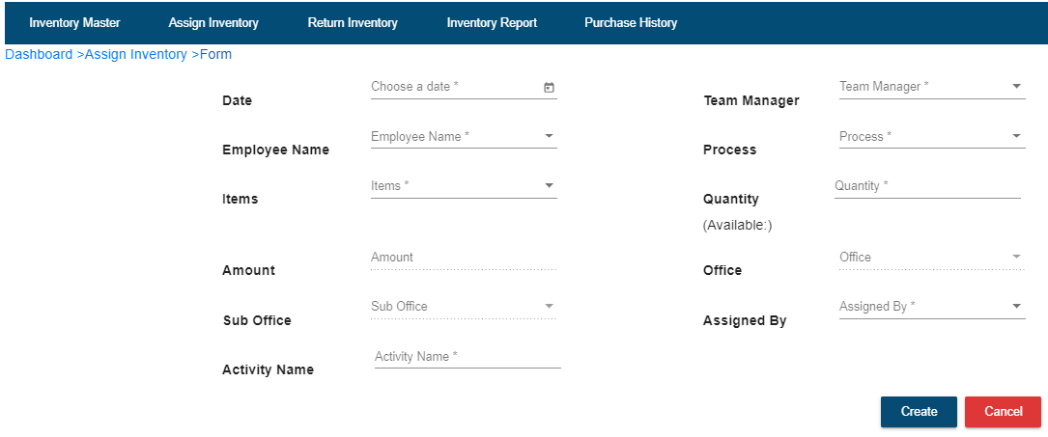

* Record get added into Assign inventory table
* User want to see details of that record then click on Book icon present in operation column.

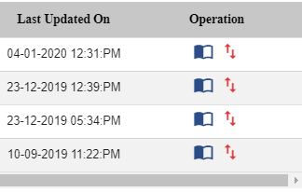

* User is able to download action log of particular record:
* Click on Upward/downward arrow in operation column



* Click on Ok to download action log sheet otherwise click on cancel.
* If you click on Ok action sheet get downloaded like below mentioned sheet.



**3. Return Inventory: -**

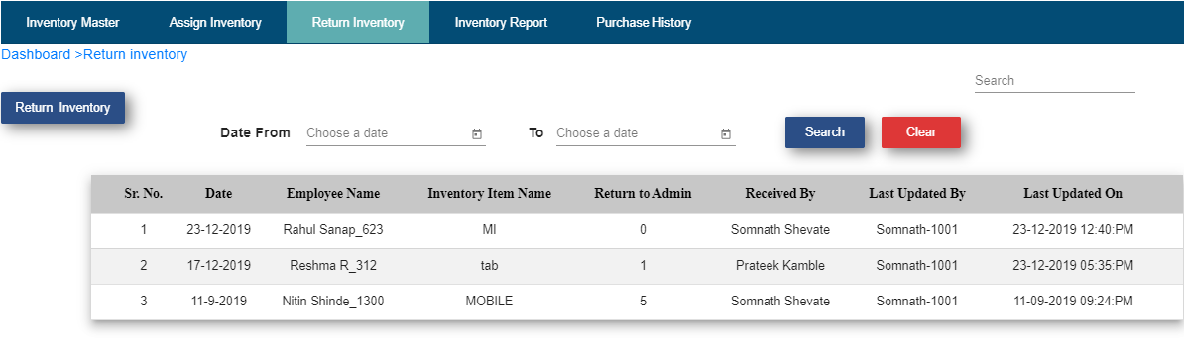

* Click on Return Inventory

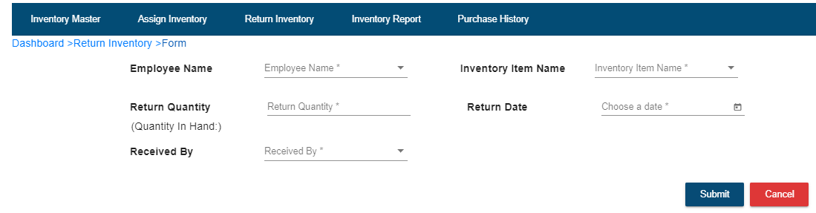

* Fill up the form
* Click on Submit button
* Click on Ok
* If you want to cancel then click on Cancel button
* All return item details are displayed in table

**4. Inventory Report: -**

* Click on Export Excel

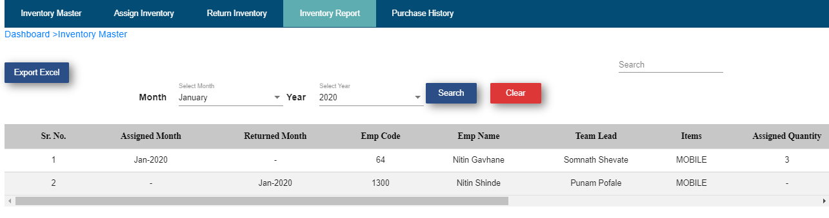

* Click Export button on popup window
* Click on Ok
* Inventory Master Report sheet get downloaded

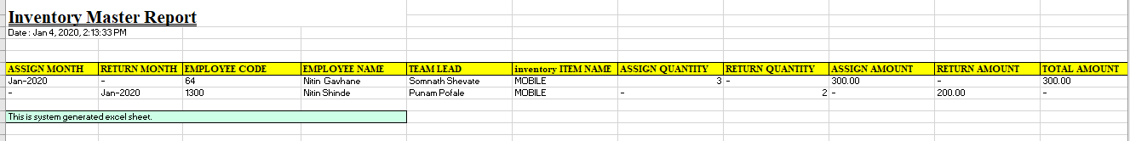

**5. Purchase History: -**

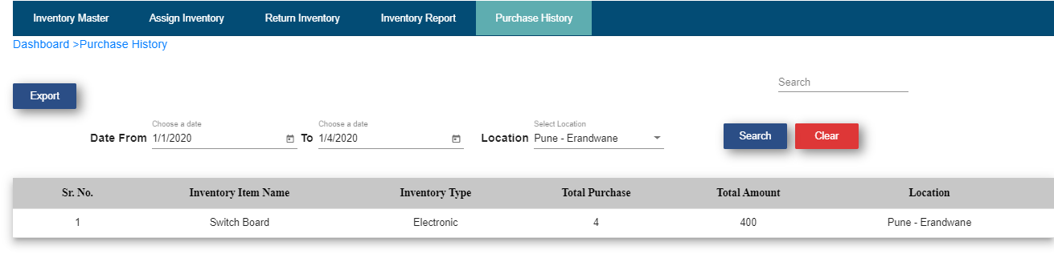

* Click on Export
* Click on Export button on popup window
* Click on Ok
* Purchase History sheet get downloaded

